

Route risk assessment

Running on pavements and canal accessible by the general public.

Route – 5K circular route from Bridge Inn Dane Road
HAZARDS | Who might be harmed? | Settings (physical settings & activities) | Mitigations
Injury from traffic and accidents | Group leaders, runners, members of public | Canal | Canal is unfenced with deep water to one side. Paths are narrow in places. Paths are used by members of public, runners, cyclists, dog walkers.  Attendees to pass other path users with care. Where necessary run in single file.  Narrow cobblestone section under Sale bridge where care should be taken.  Speed reduction barriers are in place adjacent to Springfield School and priority make need to be given to other path users.
Injury from traffic accident | Group leaders; runners; members of the public | Routes | The route on main roads with pavements that are well lit.  All attendees will be encouraged to wear high vis when it is dark  There are a number of crossing points where caution should be exercised:  - Marsland Road/Hope Road – there is a traffic island/lights which should be used  - Wardle Road/Northenden Road – there is a pelican crossing which should be used

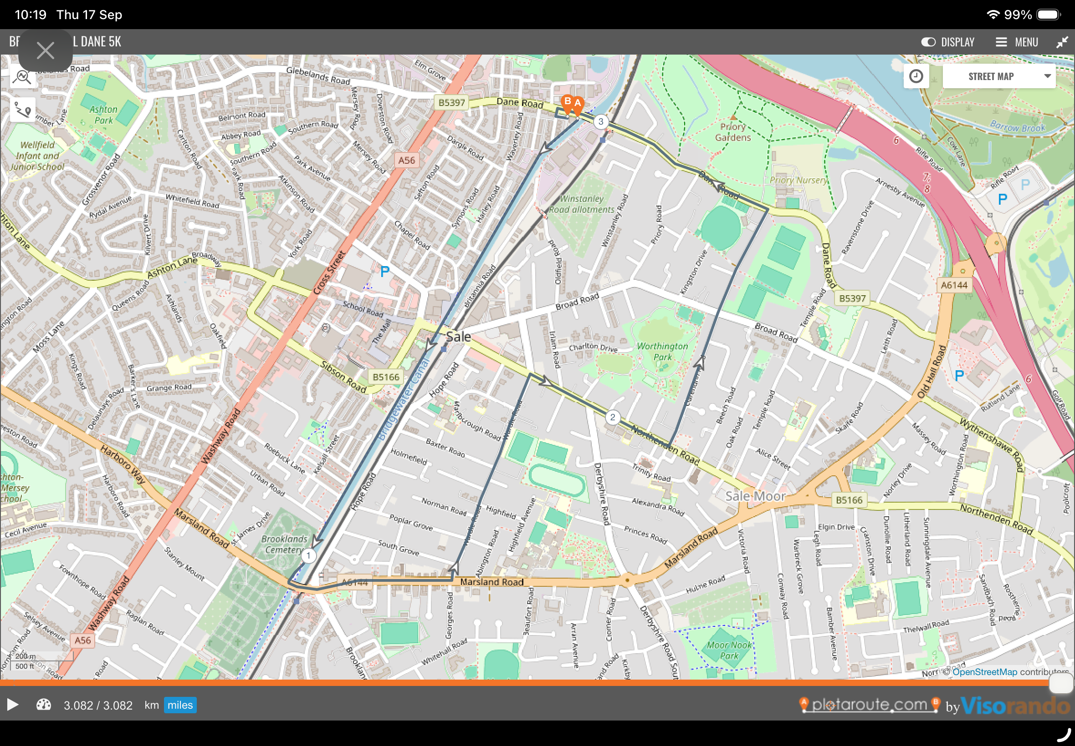
The route can be seen at https://www.plotaroute.com/route/3436795

