Risk Assessment: Club run

Date: | Assessed by: | Location : | Review :
10/02/2026 | Sue Trentini | Dunham Massey circular route from Twisted Running shop.  Broadheath / Dunham (Greater Manchester, UK) | 10/02/2027

What are the Hazards? | Who might be harmed and how? | What are you already doing? | Risk Rating | What else can you do to control this risk? | Resultant Risk Rating | Action by whom | Target date | Complete
Collision with vehicles, cycles and members of the public | Group leaders; runners; members of the public | - Routes should be on well-lit main roads with pavements, residential streets with pavements and lighting, lanes where traffic is light and slow moving and visibility is good or on trails  - Issues with darker streets or heavier traffic should be included at the run briefing  - Routes should be selected by qualified run leaders and assessed for additional risks  - Run leaders highlight any unusual risks before the start of a run  - Run leaders should carry a phone with them in case of any incident  - There should always be at least one qualified run leader for every 12 runners so that runners can be supervised and any issues dealt with  - Runners should use safe crossing points on roads  - Runners should be aware of other road and trail users and give way when necessary  - In line with England Athletics guidance, a member should not run with a dog on a club run that takes place on roads. A runner may be accompanied by one dog on a fully off-road run subject to a risk assessment being carried out by the run leader | L | Identify and list key crossing points/junctions for the route card/briefing.  Consider a marshal at the busiest crossing if group size is large or visibility is poor. | L
Trips and falls | Group leaders; runners | - Runners should wear suitable footwear (road running shoes or trail shoes as appropriate)  - Runners should wear high viz and/or head torches when it is dark (individual running torches are mandatory on trails in the dark) and leave a gap between themselves and the runner in front.  - Any surfaces considered to be higher risk should be flagged in a route specific risk assessment  - Runners should take extra care to avoid potholes/tree roots etc and should walk if unsure of foot stability.  - Run leaders should carry a phone with them in case of any incident  - There should always be at least one qualified run leader for every 12 runners so that runners can be supervised and any issues dealt with  - Routes should be selected by qualified run leaders and assessed for additional risks | M | After heavy rain, consider switching to an all‑road alternative or shortening off‑road sections.  Add a specific note to the briefing about any known muddy/technical segments. | M
Personal safety | Group leaders; runners | - Runners should be encouraged to run in pairs, small groups or as a large group if necessary. There should be no solo running on trails when it is dark  - All runners should book a place on a run and provide emergency contact information, accessible to run leaders  - The run leader should check that all runners have returned safely  - A run leader (or their nominee) should run at the back of the group to ensure no one gets left behind  - A route map should be circulated by the run director before a run and runners should ensure they are familiar with the route  - A brief description of the route in the run briefing is advisable.  - New runners should be buddied up  - Run leaders should ensure that runners know what kit will be needed to carry out the run safely  - If there is a weather warning or bad weather forecast when a run is due to take place the run should be cancelled or advice on gear given if the run director considers there is a risk to runners. Runs should be cancelled if there is an amber or red weather warning covering the route at the time of the run  - Routes should be selected by qualified run leaders and assessed for additional risks | M | Agree and communicate 3–5 fixed regroup points (e.g., at km 2/5/8) and a clear ‘lost runner’ procedure (stop/regroup/call). | M
Runner health and injury |  | - Run leaders should be clear in advance of the run about the distance of the route, the nature of the route (flat/hilly, pavement/trail etc) and any specific running gear needed  - Runners should not join a run if injured or if advised not to run by a healthcare professional  - Runners with an ongoing medical condition that may have an impact on a run should alert the run leader and carry any necessary medication  - Routes should be selected by qualified run leaders and assessed for additional risks  - Runners should only join a run if they are able to complete the distance and safely navigate the terrain  - Runners should be encouraged to be fully warmed up before the start of a run and to stretch afterwards  - Run leaders should carry a phone with them in case of any incident | M | Ensure at least one leader carries a small first aid kit and knows the nearest road access points for emergency services (or has What3Words / grid ref for regroup points). | M
Adverse weather and poor visibility (wind, ice, fog, heavy rain) | Runners; run leaders | • Leaders monitor forecast and cancel/modify in line with club policy; extra kit guidance issued when needed.  • In low light: torches/hi‑vis; reflective kit encouraged.  • Leaders shorten/alter route if conditions become unsafe. | M | Add a ‘go/no‑go’ check before start (ice/flooding/wind). For winter evenings, prefer the better‑lit sections and reduce time on off‑road parts. | M
Off‑road specific hazards (gates/stiles, livestock, farm traffic where present) | Runners; members of the public; land users | • Leaders brief runners to respect rights of way, close gates, and give livestock space.  • Keep noise down near residential/farm areas; follow any signage.  • If farm vehicles are encountered, runners step aside and allow safe passage. | M | Include a reminder in the briefing about seasonal hazards (mud, cattle) and to avoid running through fields if the right of way is unclear. | M
Water / edge hazards (ditches, ponds, streams) where present | Runners | • Leaders warn runners to keep away from edges and avoid slippery banks.  • Pace controlled on narrow sections; no pushing/passing. | M | Flag any specific edge sections in the route notes. In poor light or icy conditions, divert away from water edges if possible. | M
Navigation / wrong turns (route partly off‑road) | Runners | • Route map shared in advance; leaders familiar with route.  • Regular regroups and headcounts. | M | Carry the GPX on a phone/watch for at least one leader and brief the group on ‘if you reach X landmark, you’ve gone wrong’ cues. | M
Spread of Covid-19 |  | - Separate risk assessment produced (https://saledragons.org.uk/regular-runs-2/coronavirus-update/)

Map of route measured in miles:

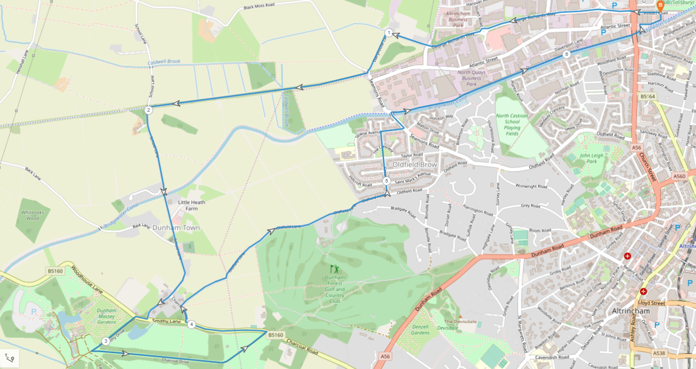

Breakdown of route hazards:

Section of route | Risk | What can be done to minimise the risk
Mile 1 | - Runners need to cross Manchester Road which is a busy crossroad.  - Road traffic frequently passes down George Richards Way.  - Dairyhouse Lane does not have a pedestrian foot path.  - Runners need to cross Seamons Road.  - TransPennine Trail can be a slip hazard when wet and may contain tree debris.  - Horses frequently use the TransPennine Trail. | - Runners should cross Manchester Road using the pedestrian crossing.  - A foot path is available for the whole section of the route.  - On Dairyhouse Lane, runners are to keep an awareness for any passing traffic. The road is wide enough for pedestrians and two lanes of traffic with a grass verge present if required.  - This is generally a quiet road at this time of the day (Sunday morning) but runners need to be vigilant for any traffic when crossing the road.  - Runners should wear appropriate shoes and take care along the trail, slowing down if/when required.  - Runners should slow down if horses are present, and be courteous to other trail users
Mile 2 | - Runners need to use steps to access School Lane from the TransPennine Trail.  - School Lane has a short section where there is no pedestrian pavement.  - Runners need to cross Smithy Lane and enter Dunham Massey National Trust via a wooden Stile with steps. | - There is a handrail along the steps to support with climbing them safely. They are made of wood which can be slippery when wet.  - There is a grass verge which runners can use if required. This road is not typically busy on a Sunday morning and is wide enough for traffic and pedestrians.  - The road is on a slight bend but traffic from both directions can be seen. The Stile has a handrail. Runners should be vigilant for the steps being slippery if wet.
Mile 3 | - Runners need to cross a second stile to exit Dunham Massey onto Charcoal Road. | - The Stile has a handrail. Runners should be vigilant for the steps being slippery if wet.
Mile 4 | - Runners need to cross Charcoal Road.  - Absent pavement on the second sections of Charcoal Road. | - There is a pavement along Charcoal Road and traffic can be visualised in both directions.  - There is a very short section of road on Charcoal Road that does not have a pavement. Runners will need to be vigilant for passing traffic. It Is wide enough for pedestrians and traffic.
Mile 5 | - Narrow bridge for pedestrians and traffic. | - Runners should wait until the bridge is clear of traffic before crossing it. There are traffic lights in place to control the movement of traffic. Runners should wait until the lights are on red to cross.
Mile 6.2 | - Tree debris and roots present along the canal. | - Runners should take care observing for tree debris and roots when running.

