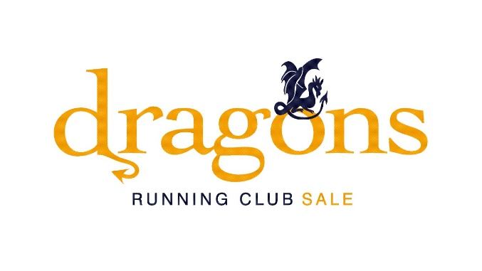
Dragons Running Club (Sale) Minutes of Annual General Meeting
15th April 2025; 7.15 pm
Venue: Trafford MV RFCC (“Metroviks”), Finney Bank Road, Sale, M33 6LR

Present
Members
Jen Bennett, Andy Blackburn, Andy Buskiewicz, Martyn Cassidy, Vicki Cleall, Hannah Dyson, Phill Edwards, Hollie Francis, Greig Frankland-Wilkinson, Rebecca Heslop, Madeleine Hill, Stephen Hodges, Stephen Jewell, Mark Jolly, Claire Kerman, Katharine Lay, Becky Lofthouse, Margot Maybury, Paul Maybury, John McIntyre, Ceri Murray, Geoff Paley, Ruby Riley, Rebecca Smithson, Paul Stansbury, Sue Trentini, Lisa Walker, Lisa Wormleighton, Dennis Yarwood, Ian Yarwood

Committee
Jane Damerum, Tracy Dique, Andy Land, Ivan MacIntyre, Paulette Storey, Sue Strickland, Rob Todd, Holly Waddell

Introduction (Jane Damerum)
Jane welcomed everyone to the meeting and introduced the committee.

Finance report (Tracy Dique)
Tracy presented the financial statement.

Dragons accounts 3 March 2024 – 3 March 2025

Opening balance at 3/3/24 | £1185.52
Debits | £ | Notes
Misc IT costs/trophies and engraving/Xmas do, London marathon place | 1344.81 | London marathon place ballot winner Becca Heslop
Track – payments out | 2000.00 | To Altrincham & District Athletics Club for use of track
England Athletics affiliation fee | 200.00
Club wear | 1501.60
Training | 1201.20 | Incl Run Leader licence renewals, Coaching course (Paul M, Paulette S)
Cross country | 325.00 | Affiliation fee and runners’ entry fees
Trafford Trails | 1631.97 | Nifty timing costs. runners’ goody bags, signs
Trafford Trails charity donations | 1181.90 | BANA, Mayor’s Charity, MND Association
Total | 9386.48
Credits
Track – payments in | 2464.00
Membership fees | 1808.68
Club wear sales | 1976.80
Trafford Trails entries | 3307.80
Xmas do deposits | 1314.30
Marshalling | 759.00
Total | 11630.58
Closing balance at 3/3/25 | 3429.62

Membership (Rob Todd)
Membership continued to grow and there were 164 members, including second claim members, as of 31st March. This was divided equally between male and female members. Renewals are now underway for 2025-26 and we have already had 110 renewals.

The membership fee was increased to £32 this year to include the increase in the England Athletics (EA) affiliation fee (up £50) and per member fee (£19) that the club pays to EA. The remainder goes to the club to carry out our activities.

Welfare Officers’ report (Sue Strickland)
Sue introduced herself and Andy Land - the club’s two welfare officers - and outlined their role. This includes responsibility for safeguarding members where applicable and production and maintenance of risk assessments for club running routes. Members are welcome to speak to Sue or Andy about any welfare issue.

Review of club activity 2024 (Holly Waddell)
Club runs
Numbers of members attending the club runs had rocketed over the past year.

We introduced a regular weekday summer morning run, pacing groups for the Tuesday 5k run and a monthly 7k option and No Pressure 10k on Thursdays.
The Elite Back Runners group had formed and ran regularly on both Tuesdays and Thursdays.

We also recruited volunteer run buddies who ensured that people new to the club runs were welcomed and did not run on their own.

The Wednesday track sessions have continued to be well attended and Paul M and Paulette had gained their coaching qualification.

Club championships
The club championship and parkrun championship had also been well attended and in addition had been good promotion for the club.

X country
We again took part in the Manchester Area Cross Country League with 36 members running for the club. Bad weather led to one event being cancelled and being rearranged so only 4 events took place again this year.

Trafford Trails
We had another successful Trafford Trails event in July and Pilates Manchester were thanked for sponsoring the prizes. The profits were shared between the Motor Neurone Disease Association (MND), the Mayor’s Charity and British Acoustic Neuroma Association (BANA), nominated by club members, and Dragons.

Manchester 24 hour run against homelessness
A number of Dragons had also taken part in the Manchester 24 hour run against homelessness, running some very impressive distances.

Manchester Marathon marshalling
This raises funds for the club each year and we again had an excellent turnout of volunteers to marshall.

This Dragons on Fire
This Dragons on Fire certificates were awarded to a number of members in recognition of a range of amazing achievements. Members are encouraged to send in nominations for a Dragon on Fire.

Social activities (Jane Damerum)
There were a whole range of activities during the year, including meals out, bowling, pub quizzes and social runs and a number of people took part in races abroad. Suggestions for activities are always welcome.

Election of committee for 2025 (Tracy Dique)
Tracy Dique, Sue Strickland and Holly Waddell were stepping down from the committee. Much appreciation and many thanks were given to them for all their contributions.
The other committee members were happy to re-stand for the coming year. The committee proposed the following members for election to the committee:
Jen Bennett
Becca Heslop
Mark Jolly
Becky Lofthouse
Geoff Paley
Rebeccca Smithson
Steven Ward
and they were elected, together with Jane Damerum, Andy Land, Ivan Macintyre, Paulette Storey and Rob Todd, to the committee for the coming year.

Plans for 2025 (Jane Damerum and Andy Land)
Club sessions and championships
The Tuesday and Thursday club runs and Wednesday track session are continuing, the club championship and parkrun championship are both taking place again this year and we will again be entering the cross country league competition run by Manchester Area Cross Country League. There is no charge to members to take part in cross country as the entry fees are paid by the club and members are encouraged to take part.

Club outings
There is a club outing to Chevin Forest parkrun on May 31st.

Booking system
A new booking system for club sessions – Spond – is being introduced from 1 May. This should make it easier to book on to runs and also provides run leaders with easy and instant access to individuals’ emergency contact information, should this be needed.

Interclub event
Sale Harriers have invited us, Altrincham, Didsbury and Chorlton clubs to take part in a handicap race in May. This is intended as a trial for this year with a view to continuing if successful.

Unofficial walking group
Tracy gave information on the formation of a walking group for former, injured or no longer running Dragons. The walks will be around 4 miles to 11k on Sunday mornings. The group has its own Facebook page where it publicises the walks. Tracy Dique can provide further information.

Club banner(s)
David Hiley, on hearing that the club banner had vanished, had arranged for 13 new Dragons banners to be produced and given them to the club. Grateful thanks were given to David. The new banners will be on show at various points of the Manchester Marathon course. Lisa Wormleighton volunteered to be banner monitor for the day and ensure their distribution and safe return.

Coaching
Paulette and Paul had gained the EA coaching qualification and outlined some ideas for development for club members.
This included:-
- more work on drills on track evenings
- observation and feedback on running form with suggestions on ways to improve
- a track programme for beginners
- other coached club sessions, for example, hills, tempo, longer speed intervals, fartlek
- help and advice on running in general, for example, principles of training in general, how to train - both to improve and to reduce the likelihood of injury or burnout
- help and advice on specific queries such as training for specific distances, what does a training programme for a race look like
- ways of sharing the knowledge and experience of members on a whole range of issues, including, kit, tech, nutrition, other activities to support running eg strength and conditioning, work on agility, balance and co-ordination or “Ask the Coach” for individuals.

Views from members on these ideas and any other suggestions are encouraged and welcomed. These ideas will be progressed by Paul and Paulette.

Club trail runs
It was suggested that the club arrange some trail runs as a social activity. This will be progressed by the committee.

Members were thanked for attending and the meeting closed and the buffet began.

